Nepal College of Information Technology
Unit Test
Fall 2011
Program : BE ELX Time : 2 hrs
Semester : Fall (V) FM : 70
Subject : Control System PM : 35
- Candidates are requested to give their answer as far as practicable in their own words.
- The figure in the margin indicates the full marks
- Attempt ALL question
1. a) Differentiate between open loop and closed loop control systems with suitable examples. [8]
b) A position control system is shown in figure below
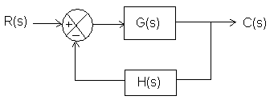
where G(s)= 10/{s(s+1)} ; H(s)=5
Calculate the sensitivity of the closed-loop transfer function, M with respect to the forward path gain G. [7]
2. a) A closed loop system can become unstable under certain condition. Illustrate the statement with suitable reasons. [7]
b) Obtain the mechanical system for the electrical system shown in figure. [8]
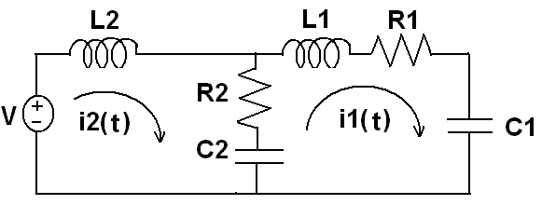
3 A mechanical system is represented as shown in the figure below:
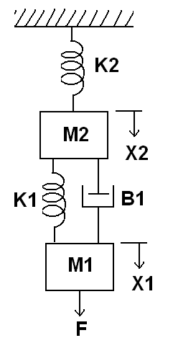
Obtain the mechanical equations and also draw the force voltage analogy and force current analogy of the given system. [15]
4. a) Write down the defining equation for the liquid level system shown in the below figure. Obtain their transfer function also. [7]
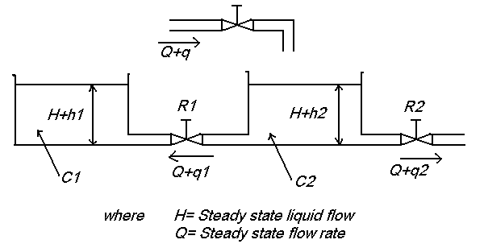
b) Draw the overall block diagram for field controlled DC motor. Also find the overall transfer function. [8]
5. Write short notes on (any two) [5*2=10]
a) Linear approximation of non-linear system
b) Sensors
c) Human control system

